**3. Decision and Loops:**

Name: PAWAN KUMAR MEENA

Roll No:21UFIE2085 Branch : cse

**1.** [**C Program to Find Factorial of a Number**](https://www.programiz.com/c-programming/examples/factorial)**.**

**Program::**

#include<stdio.h>

int main (){

int num,fact=1;

printf("Enter the number::\n");

scanf("%d",&num);

for (int i = 1; i <=num; i++)

{

fact = fact*i;

}

printf("Factorial of %d = %d",num,fact);

return 0;

}

**Output::**

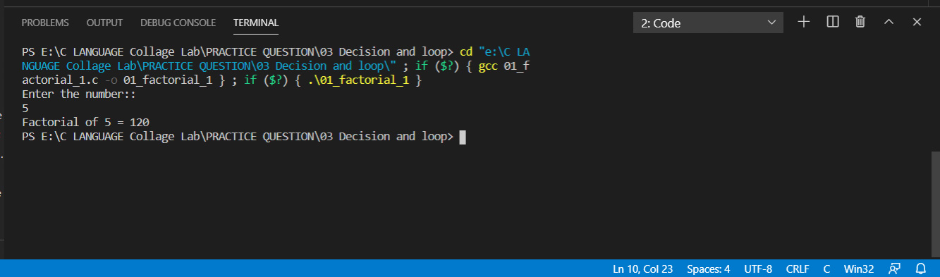

**2.**[**C Program to Generate Multiplication Table**](https://www.programiz.com/c-programming/examples/multiplication-table")**.**

**Program::**

#include<stdio.h>

int main (){

int num;

printf("Enter the number that you want to Multiplaction Table::\n");

scanf("%d",&num);

printf("::::Multiplation Table of %d::::\n\n",num);

for (int i =1; i <=10; i++)

{

printf("%d * %d = %d\n",num,i,num*i);

}

return 0;

}

**Output::**

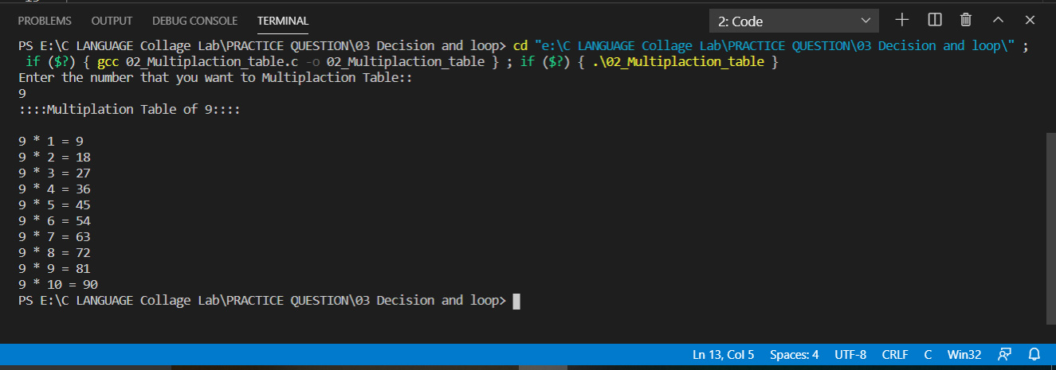

**3.**[**C Program to Display Fibonacci Sequence**](https://www.programiz.com/c-programming/examples/fibonacci-series")**.**

**Program::**

#include <stdio.h>

int main()

{

int num, result, t1 = 1, t2 = 1;

printf("Enter the number which you want fibonacci series:\n");

scanf("%d",&num);

if (num == 0)

{

result = 0;

}

else if ((num == 1) || (num == 2))

{

result = 1;

}

else

{

for (int i = 2; i < num; i++)

{

result = t1 + t2;

t1 = t2 ;

t2 = result ;

}

}

printf("Fobonacci value of %dth terms = %d", num, result);

return 0;

}

**Output::**

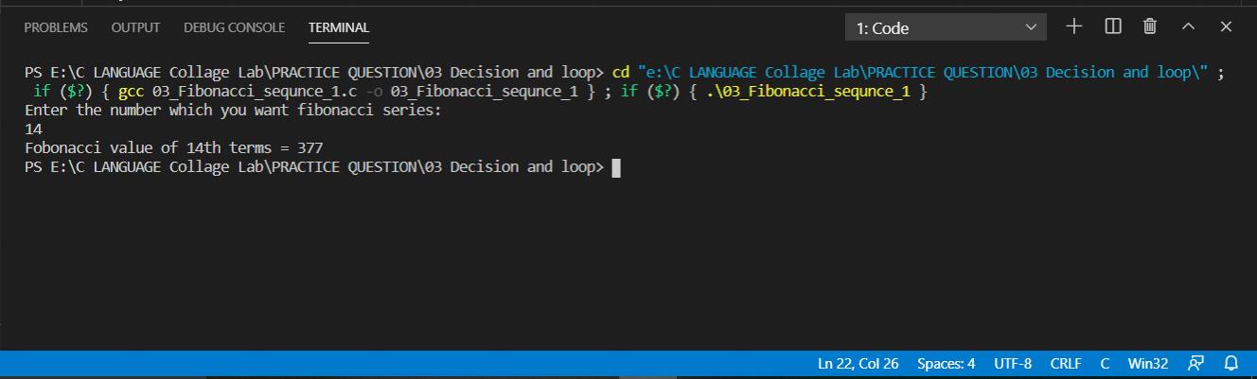

**4.** [**C Program to Find GCD of two Numbers**](https://www.programiz.com/c-programming/examples/hcf-gcd)**.**

**Program::**

#include <stdio.h>

int main()

{

int num1, num2, gcd = 1;

printf("Enter the value of number1 and number2::\n");

scanf("%d%d", &num1, &num2);

for (int i = 1; i <= num1 && i <= num2; i++)

{

if (num1 % i == 0 && num2 % i == 0)

{

gcd = i;

}

}

printf("G.C.D of %d and %d is %d", num1, num2, gcd);

return 0;

}

**Output::**

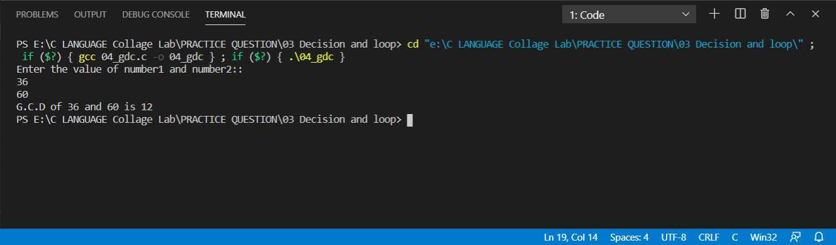

**5.** [**C Program to Find LCM of two Numbers**](https://www.programiz.com/c-programming/examples/lcm)**.**

**Program::**

#include <stdio.h>

int main()

{

int num1, num2, gcd = 1, lcm;

printf("Enter the value of number1 and number2::\n");

scanf("%d%d", &num1, &num2);

for (int i = 1; i <= num1 && i <= num2; i++)

{

if (num1 % i == 0 && num2 % i == 0)

{

gcd = i;

}

}

lcm = (num1 * num2) / gcd;

printf("LCM of two number %d and %d = %d\n", num1, num2, lcm);

return 0;

}

**Output::**

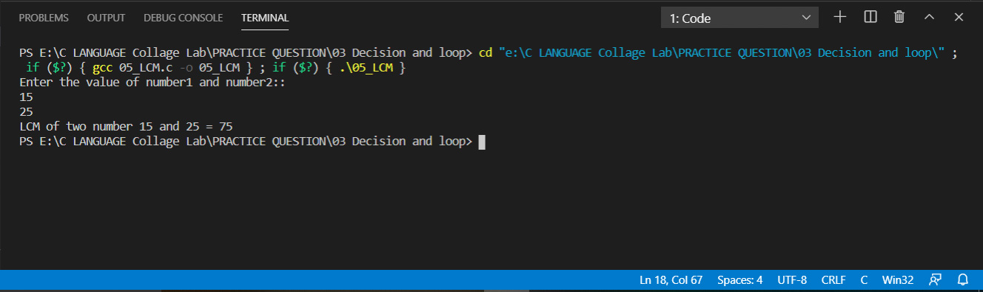

**6.** [**C Program to Display Characters from A to Z Using Loop**](https://www.programiz.com/c-programming/examples/display-alphabets)**.**

**Program::**

#include<stdio.h>

int main (){

for (int i = 65; i <=90; i++)

{

printf("%c\t",i);

}

return 0;

}

**Output::**

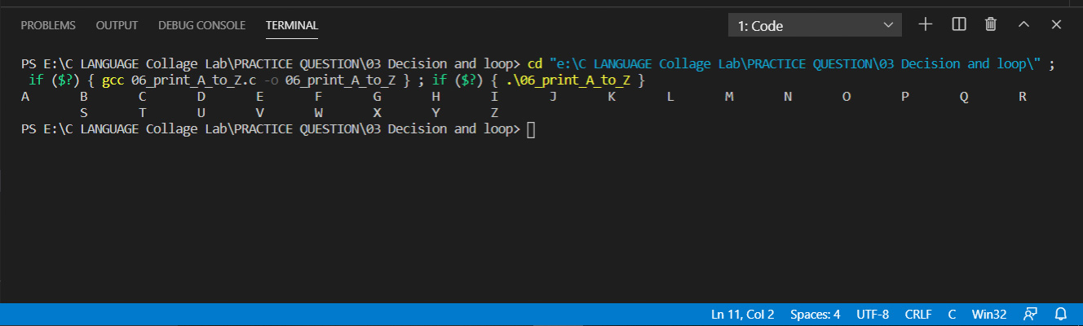

**7.** [**C Program to Count Number of Digits in an Integer**](https://www.programiz.com/c-programming/examples/digits-count)**.**

**Program::**

#include<stdio.h>

int main (){

int num,count=0;

printf("Enter the number::\n");

scanf("%d",&num);

int n1=num;

for (int i = 0; num!=0 ; i++)

{

count++;

num = num/10;

}

printf("In the %d number total digit = %d\n",n1,count);

return 0;

}

**Output::**

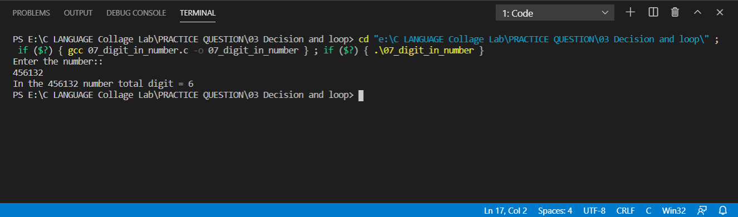

**8.** [**C Program to Reverse a Number**](https://www.programiz.com/c-programming/examples/reverse-number")**.**

**Program::**

#include <stdio.h>

int main() {

int n, rev = 0, remainder;

printf("Enter an integer: ");

scanf("%d", &n);

while (n != 0) {

remainder = n % 10;

rev = rev * 10 + remainder;

n=n/10;

}

printf("Reversed number = %d", rev);

return 0;

}

**Output::**